Introduction

Förster Resonance Energy Transfer (From here on referred to as “FRET”) can be understood from the following “radio-analogy.” Imagine a radio-sender and a radio-receiver at very low power with the sender-receiver distance much smaller than the wavelength of the radiation. This is a highly unusual application of radio, but what happens between sender and receiver in this so-called near-field (that is, at separation distances much smaller than the wavelength) is very similar to what happens in FRET. In FRET you have a donor (like a sender) and an acceptor (like a receiver). Both in FRET and in near-field-radio electromagnetic interactions play a role, the difference is only in the size of the wavelength (radio uses wavelengths in the 103 to 106 meter range, FRET in the 10-7 to 10-8 meter range). In both, resonance is essential. In both, radiation does not occur but energy is transferred from the sender/donor to the receiver/acceptor. Both have antenna-like objects but they have a different name in FRET. The antenna-like object in the donor is called the emission transition moment and that in the acceptor is called the absorption transition moment. In radio, antennas have certain characteristic shapes. In FRET, the transition moments may undergo coupling or rapid reorientations at frequencies higher than GigaHertz. FRET is extremely sensitive to small changes in distance between molecules, allowing for a detailed view into the positioning of molecular structures relative to each other. This has been referred to as a “spectroscopic ruler”, a term first coined by Stryer and Haugland.[1] Because of its ability to peer into intermolecular and intramolecular interactions between parts of molecules, FRET has many applications in biology and chemistry. It can be used to detect interactions between proteins, movements of proteins, and protein deformation among other things.

J. Perrin came up with a theory relating the transfer mechanism of FRET, the wavelength, and the average time between dye-solvent collisions, but, at the time of his work, his theory was largely untestable.[2] Theodor Förster, however, made FRET more experimentally verifiable with his paper “Intermolecular Energy Migration and Fluorescence” in 1948 in which he expresses the rate of energy transfer in terms of lifetimes, absorption, and emission spectra -- quantities much more accessible than Perrin’s collision times.[3] Förster also introduced a special distance, which later became known as the "Förster distance". This distance is the donor-acceptor distance at which the probability of energy transfer equals the probability of the excited donor deactivating by means other than transfer. The FRET efficiency, E, can be obtained from the donor fluorescence intensity in the presence of acceptor, IDA (DA as subscript), and that in the absence of acceptor, ID (D as subscript) as E = ID/(ID+IDA). The orientation factor in the rate of transfer or the transfer efficiency is identical in near-field radio and in FRET. This factor is called kappa-squared in FRET, and has a value between 0 and 4. This orientation factor, kappa-squared, is the main topic in the project presented here. In order to accurately estimate the distance between donor and acceptor all three quantities: FRET efficiency, Förster distance, and kappa-squared are needed. However, it is very difficult to measure kappa-squared precisely. That’s what makes the orientation factor interesting and important. It is the main topic of my research project.

In 1979, R. E. Dale, J. Eisinger, and W. E. Blumberg published “The Orientational Factor in Intramolecular Energy Transfer” pointing out that one can relate the range of kappa-squared values to depolarization values of the donor and acceptor if they are fluorescent.[4] A depolarization factor can be defined as the degree to which polarized light absorbed by a molecule is depolarized when emitted. This depolarization of light can be attributed to the Brownian motion of the light acceptor. The depolarization factor can be equal to or greater than -1/2 and smaller than or equal to 1 due to limitations imposed by the distribution function.

In this paper, Dale et al. also discuss probability distributions of the orientation factor and differences between static and dynamic averaging. The main conclusion of this ground-breaking work is that the unknown kappa-squared can be replaced by an average value. This average value depends on the depolarization factors d, for the donor, and a, for the acceptor. Both factors can have values between 1 and -0.5. The average kappa-squared also depends on 3 angles (defined below, in the Materials & Methods section). Dale et al pointed out that a minimum and a maximum for the kappa-squared can be found allowing for an estimate of the minimum and maximum distance from FRET efficiency, Förster distance, and depolarization factors. Kappa-squared is also mentioned in a highly informative video seminar by Philippe Bastiaens (<http://www.youtube.com/watch?v=nba4QwROBtA>). He mentioned that kappa-squared equals zero if the transition moment are perpendicular to each other. Is this true? Is this the only way to obtain a value of zero for kappa-squared?

Our goal has been in creating an interactive model for visualizing and calculating the orientation factor in FRET, showing the relation between the preferred directions of the transition moments and the depolarization factors. We decided this was necessary to help others better understand the relation between the orientation factor and FRET results.

Materials and Methods

My contributions to this project were designing the code necessary to visualize the variables affecting the orientation factor and to calculate the corresponding value of kappa-squared. This included determining the relation between the depolarization factors and the cylindrical and ellipsoidal probability distributions.

The acceptor and donor depolarization factors affect kappa-squared along with a few other variables:

$$〈k^{2}〉=\frac{2}{3}-\frac{1}{3}a-\frac{1}{3}d+d\left(1-a\right)\cos^{2}{Θ_{D}+a\left(1-d\right)\cos^{2}{Θ_{A}+ad{k_{1,1}}^{2}}}$$

$$with{ k}_{1,1}^{2}={\left(sin{ Θ}_{D} sin{ Θ}_{A}\cos{Φ}-2\cos{Θ_{D}}\cos{Θ_{A}}\right)}^{2}$$

Here, $Θ_{D}$ is defined as the angle between the connection vector, that is, the vector from the center of the donor to the center of the acceptor, and the donor transition moment. $Θ_{A}$ is defined by the same definition, but for the acceptor. $Φ$ is the angle between the two transition moments if they were projected onto a plane perpendicular to the vector running between the two transition moments.

I wrote code in the Mathematica programming language to create the visualization tool. I created my own dynamic module to wrap the controls for the 3D graphics and contained it all inside a panel. For each transition moment, I wrapped a sphere in a scaling function that stretches the graphic based on certain factors in the x, y, and z axis. This scaling function is what was dependent on the depolarization factor. We worked out the proper mathematical relation for the horizontal ratio (b) versus the vertical ratio (c) and depolarization factors. $$\begin{matrix}γ equals horizontal/vertical radius & γ=\frac{b}{c} \\ Relation to depolarization value, a & γ={\left(\frac{1-a}{1+2a}\right)}^{\frac{4}{5}+\frac{1}{5}a} \\ Distributing the exponent & γ=\frac{{\left(1-a\right)}^{\frac{4}{5}+\frac{1}{5}a}}{{\left(1+2a\right)}^{\frac{4}{5}+\frac{1}{5}a}}\end{matrix}$$

Since $γ$ is the ratio between the horizontal radius and vertical radius, I set the x and the y scaling equal to ${\left(1-a\right)}^{\frac{4}{5}+\frac{1}{5}a}$ and set the z scaling equal to ${\left(1+2a\right)}^{\frac{4}{5}+\frac{1}{5}a}$.

$Θ_{A}$ and $Θ_{D}$ were both represented by using a function to rotate 3D objects in space while keeping a certain point constant. They were allowed 180 degrees of freedom to represent every possible orientation. The vector between the two transition moments was represented by a rod running from the center of one transition moment to the center of the other.

$Φ$ was represented by the projection of the donor and acceptor onto a plane perpendicular to the vector running between them. I used a square to represent the plane and projected different colored lines, one for the acceptor and donor, onto the square using the “FaceForm” function. The user can control the opacity of the plane with a slider.

In the program, I also created a tool for understanding the variables that go into the visualization. Using the “TabView” function of Mathematica, I created guides to each variable and provided links to external sources for additional information.

Also included in the program were special cases which are candidates for maxima and minima [5]. The regions where one of the candidates is the maximum kappa-squared, and another is the minimum are given in reference 5. These regions and candidates have been programmed in. The equations, as listed below, don’t need $Θ_{A},$ $Θ_{D}$, or $Φ$ to find the minima and maxima:

$$κ_{A}^{2}=\frac{2}{3}+\frac{2}{3}a+\frac{2}{3}d-2ad$$

$$κ_{P}^{2}=\frac{2}{3}-\frac{1}{3}a-\frac{1}{3}d$$

$$κ_{H}^{2}=\frac{2}{3}-\frac{1}{3}a-\frac{1}{3}d+ad$$

$$κ_{M}^{2}=\frac{2}{3}+\frac{1}{6}a+\frac{1}{6}d-ad+\frac{1}{2}\left|a-d\right|$$

$$κ_{L}^{2}=\frac{2}{3}+\frac{1}{6}a+\frac{1}{6}d-ad-\frac{1}{2}\left|a-d\right|$$

$$κ_{T}^{2}=\frac{1}{9}\left(1-a\right)\left(1-d\right)+\frac{4}{9}\sqrt{(1-a)(1-d)(1+2a)(1+2d)}$$

The program was created with a set of buttons that allows the user to see what the $Θ_{A},$ $Θ_{D}$, and $Φ$ angles would be for the current acceptor and donor depolarization factors in a particular region if it exists.

Results

This program provides a much needed tool to aid in the visualization of the orientation factor in Förster Resonance Energy Transfer. It also allows one to easily calculate values for kappa-squared for any possible choice of the parameters. For any *a* and *d* value, it allows the user to calculate the minimum value that kappa-squared could be and the maximum that it could be. The tool also allows the user to see the angles associated with each combination of *a* and *d* values for each candidate region for minimum and maximum.

Using the visualizer/calculator, a few things were found:

Kappa-squared is zero in many other scenarios than just when the transition moments are perpendicular to each other. This is an oversimplification used relatively often. Kappa-squared can be zero if both depolarization factors are equal to one and if either $Θ_{D}= Θ_{A}=Φ=90°$, or, if $Θ_{D}= Θ_{A}≈54.73561°$ and $Φ = 0°$. It can also be zero if one of the depolarization factors is 1 and the other is -0.5 with $Θ_{D}=Θ_{A}=90°, Φ=0°$. It should also be mentioned that kappa-squared can be zero for an infinite number of combinations of $Θ_{D}, Θ_{A}, and Φ$ when both depolarization factors are one. (A few of these are all shown in Table 1)

The formulas for the maxima and minima presented in (<http://fretresearch.org/kappaSquaredChapter.pdf>)[5] and mentioned above were confirmed and could be seen and calculated easily. The *a* and *d* values and their relations to $Θ_{D}, Θ_{A}, and Φ$ were determined and visualized for each minima and maxima region. It was also shown that the actual kappa-squared value was always in range of the minima and maxima kappa squared values determined by the acceptor and donor depolarization factors.

Illustrations

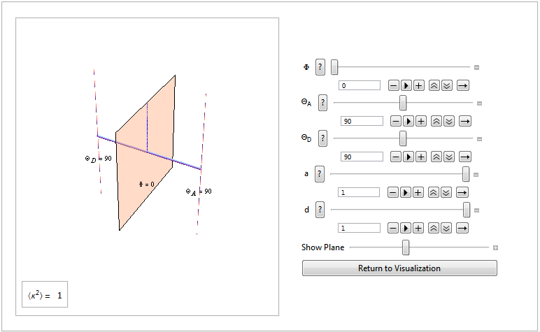

Figure 1: This is a screenshot of the program written to aid in the visualization of the orientation factor of Förster Resonance Energy Transfer. Here, we see the interactive tool when it first starts up with default values.

**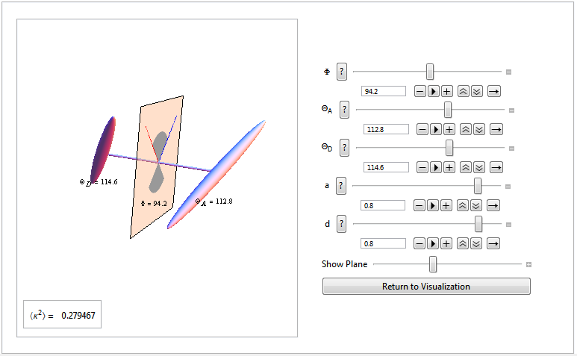**

Figure 2: This is the appearance of the visualization program after decreasing the value for "a" and "d", the acceptor and donor depolarization factors, and increasing $Φ$, the angle of the projection. Also changed are the acceptor and donor angles from the vector running through the center of the transition moment.

**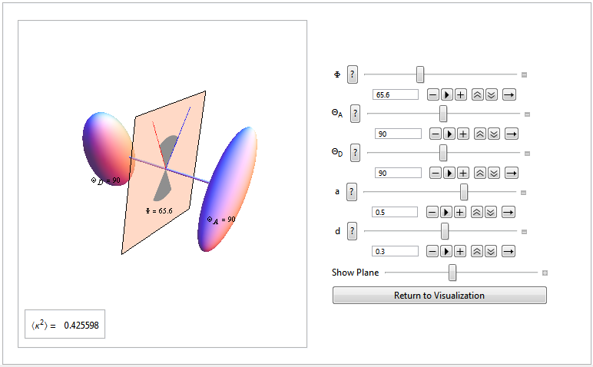**

Figure 3: Here we see a more sphere-like appearance of the probability distributions of the acceptor and donor coming from a lower depolarization factor for each. The distance from the center represents the likelihood that the transition moment will be in that direction at any point in time.

**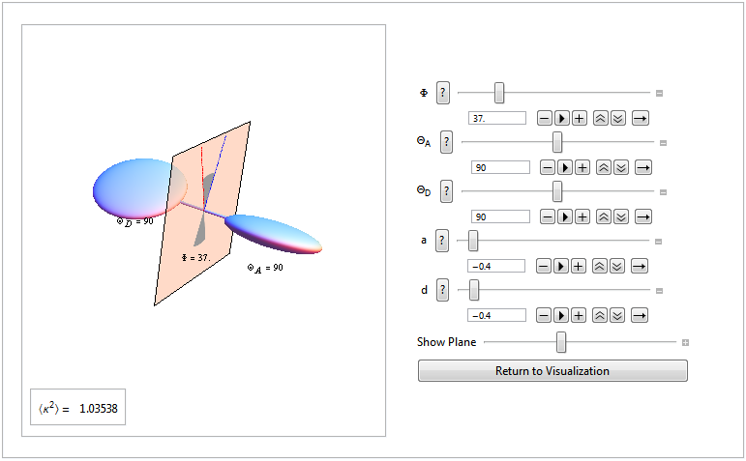**

Figure 4: Here, we can observe the negative values for the acceptor and donor depolarization factors and we can see how they are more disk-like because of this.

|  |  |
| --- | --- |
| **Table 1: Scenarios in which kappa-squared can equal zero** | |
| Scenario | Visual |
| With | C:\Users\WKUUSER\Desktop\kappazero_90degree.PNG |
| With | C:\Users\WKUUSER\Desktop\fretvisual124.PNG |
| With  or | C:\Users\WKUUSER\Desktop\fretvisual123.PNG |

Table 1: This shows a few scenarios in which kappa-squared can equal zero. This is by no means an extensive list, though. Kappa-squared can equal zero for an infinite combination of $Θ_{D},Θ_{A}, and Φ$ values when *a* and *d* values are equal to one.

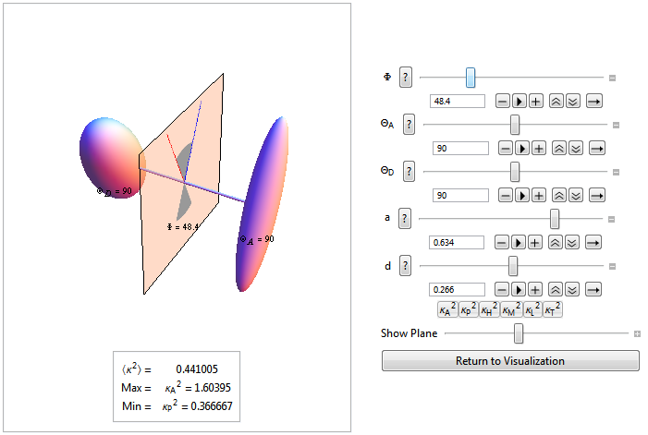

Figure 5: Here, we can see the minima and maxima kappa-squared values for the current acceptor and donor depolarization factors shown under the kappa-squared value. The maximum and minimum regions are also named.

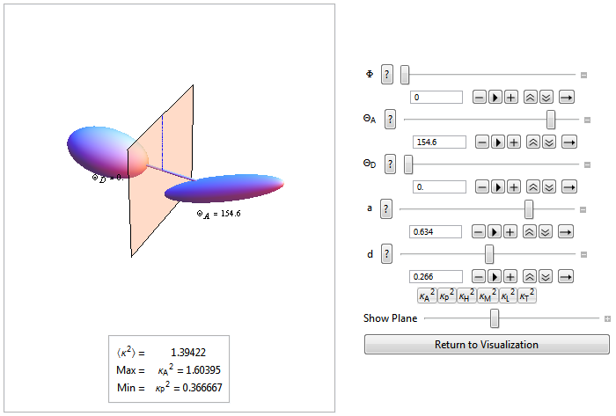

Figure 6: Here, we see the same *a* and *d* values as Figure 5, but different angles. In the picture, kappa-squared changed, but the maximum and minimum values for kappa-squared didn’t change since they are directly related to the acceptor and donor depolarization factors, not the angles.

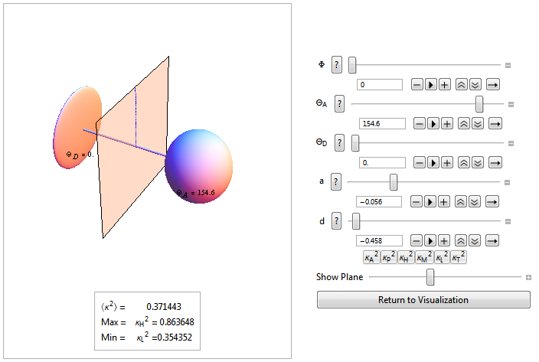

Figure 7: Here, the angles are constant and the acceptor and donor depolarization values have changed from Figure 6. As a result, the minima and maxima regions have changed.

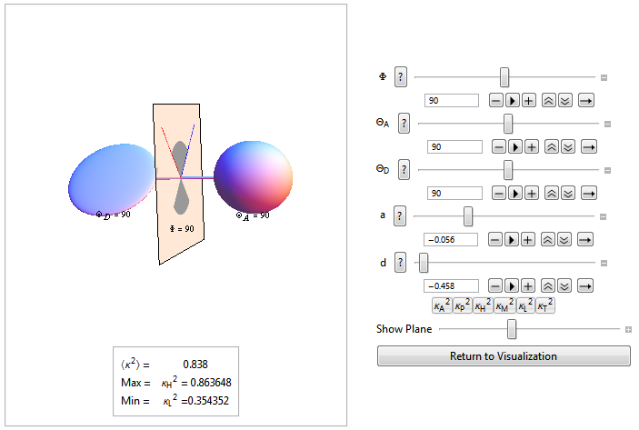

Figure 8: This graph show an angle change that occurs after pressing one of the region buttons under the *d* slider. These buttons change the angles of the visualization to the proper angle for the current donor and acceptor depolarization factors if it exists in that region.

Discussion

When the donor and acceptor transition dipoles go through all orientations in a time short compared to the transfer time, the average kappa-squared value is $\frac{2}{3}$. Kappa-squared is too often approximated as $\frac{2}{3}$ in scenarios that it shouldn’t be, leading to inaccurate efficiency values. When the distance between the donor and acceptor must be found with FRET, this blanket substitution of kappa-squared as $\frac{2}{3}$ can be especially troublesome.

After the Dale-Blumberg-Eisinger paper, it became possible to relate the kappa-squared values to observable anisotropy values. This made it possible to calculate kappa-squared with some degree of accuracy and ease, thus getting more accurate FRET measurements. This allows for measurements, such as donor-acceptor distance, taken using FRET to be achieved with much more accuracy.

Even after this paper was published, many people still continue in the kappa-squared = 2/3 approximation because of their lack of understanding regarding the orientation factor. Our program is the first interactive tool that we’ve seen for visualizing kappa-squared and understanding it more fully. Our hopes are that this tool will make it easier for people to understand and take advantage of calculating kappa-squared for their research.

It’s convenient to visualize the angles and acceptor and donor depolarization values that correlate with each kappa-squared value. Calculating the maxima and minima allows for the minimization of the range of possible kappa-squared values when less information is available.

Conclusions and Future Work

As stated before, calculating kappa-squared is very important in getting more accurate measurements in FRET. Without it, data can be off. Kappa-squared calculations usually don’t take place because of the lack of understanding. Our program provides an easy tool to aid in understanding.

Ellipsoids are not the only method that can be used to represent the probability for the acceptor and donor depolarization factors. In the future, we hope to provide the user the option to select between a cylindrical and ellipsoidal probability distribution instead of just the ellipsoidal distribution. This allows the user to visualize the depolarization factors in multiple ways.

In the paper at <http://fretresearch.org/kappaSquaredChapter.pdf>, there are formulas for maxima and minima for various values of acceptor and donor depolarization factors. We plan to build these into our visualization tool, allowing the user to choose both depolarization factors then give them the maximum and minimum kappa-squared values possible. Maxima and minima can also be calculated if the so-called transfer depolarization is known which corresponds to exciting the donor and measuring the anisotropy of the sensitized emission from the acceptor.